

Game Development assignment

Robbie the robot



October 26, 2016

Joe ZIpeto

1009624441

Table of Contents

[Detailed Game Description 2](#_Toc465287064)

[Controls description 2](#_Toc465287065)

[Interface Sketch 3](#_Toc465287075)

[GamePlay 3](#_Toc465287076)

[GameOver 3](#_Toc465287077)

[Screen Descriptions 4](#_Toc465287078)

[Start Of Game 4](#_Toc465287079)

[Gameplay 4](#_Toc465287080)

[End Of Game 4](#_Toc465287081)

[Enemies 5](#_Toc465287082)

[Scoring 5](#_Toc465287084)

[Sound Index 5](#_Toc465287093)

[Art / Multimedia Index 6](#_Toc465287094)

Detailed Game Description

Robbie the Robot loves running through the forest and collecting coins. He loves it so much he can’t stop running. But he has to be careful not to crash into the many trees in his path since they can hurt him – too many collisions and Robbie can’t collect anymore coins.

Controls description (1 Mark: External Documentation).

|  |  |  |
| --- | --- | --- |
| Direction | Right-Handed | Left-Handed |
| Up | C:\Users\joe_z\OneDrive\Documents\icon-arrow-up-b-128.png | C:\Users\joe_z\OneDrive\Documents\letter-w5.png |
| Down | C:\Users\joe_z\OneDrive\Documents\download.png | C:\Users\joe_z\OneDrive\Documents\images.png |

Interface Sketch

## GamePlay

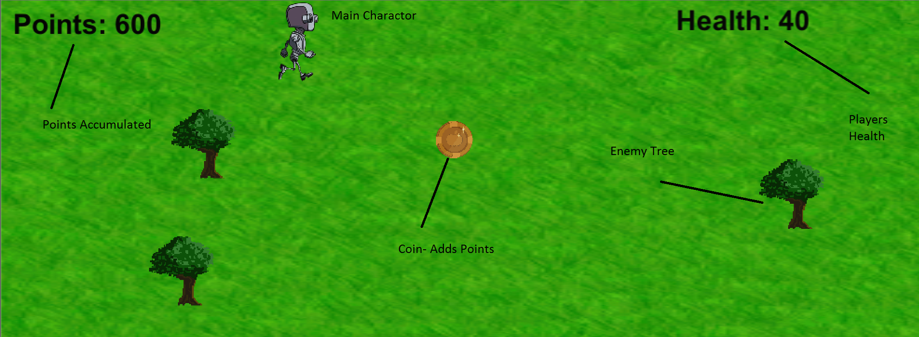

## GameOver

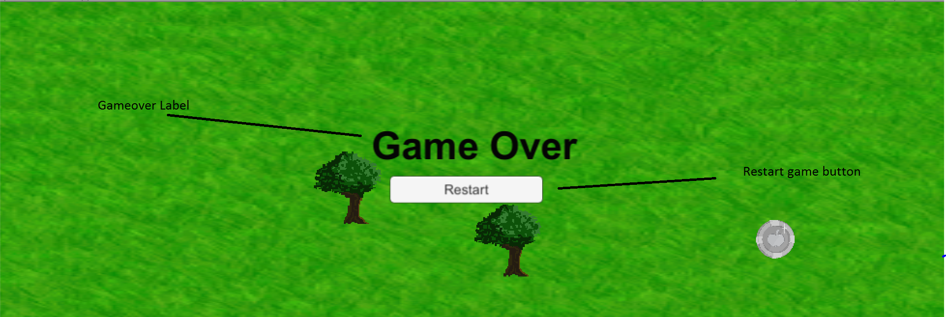

Screen Descriptions

## Start Of Game

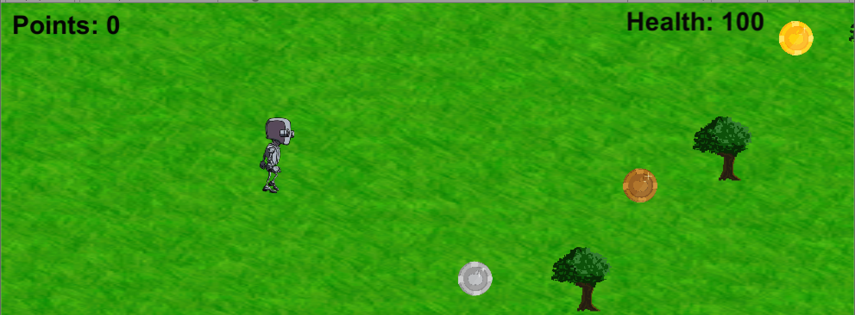

## Gameplay

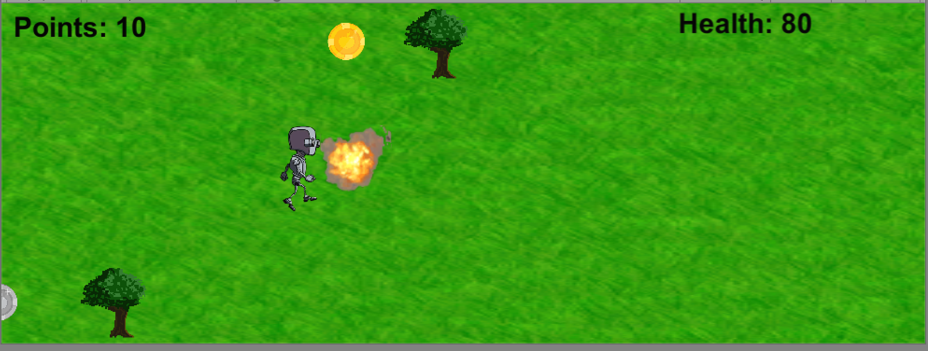

## End Of Game

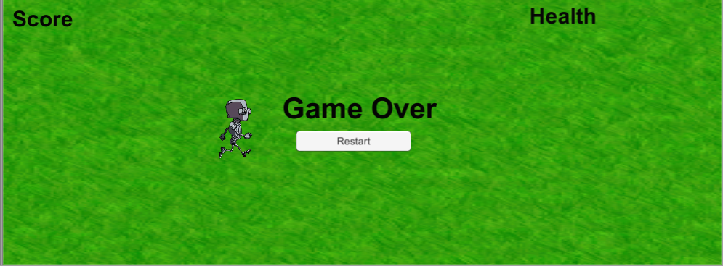

Enemies – Describe the computer controlled enemies and how they function (0.5 Mark: External Documentation).

The enemies are Trees that Robbie can hit while collecting coins. Robbie is running through a forest

Scoring

There are gold, silver and bronze coins which each will give you different points as you collect them.

|  |  |
| --- | --- |
| Gold Coin | 100 points |
| Silver Coin | 50 points |
| Bronze Coin | 10 points |

Trees will cost you 20 health. If you hit 5 trees the game over screen will come up and you will have to restart the game.

Sound Index

|  |  |
| --- | --- |
| Background Music | <http://www.soundjig.com/pages/music/technohousetrance.html> |
| Coin collecting sound | Coin asset package |
| Tree Explosion sound | 2d explosion asset package |

Art / Multimedia Index

|  |  |
| --- | --- |
| **Tree** |  |
| **Gold Coin** |  |
| **Silver Coin** |  |
| **Bronze Coin** |  |
| **Robbie the Robot** |  |
| **Grass** |  |

These where mostly from the 2d sprites and the coins are from the coin asset package.